To correct printer error in remote FE sessions when running reports

Access printers and scanners in one of two ways

Click on the start button and simply type printers – when it pops up simply select it

OR click on the start button\settings\devices and select printers and scanners on the left side of the window.

FIRST uncheck the box for “let windows manage my default printer”

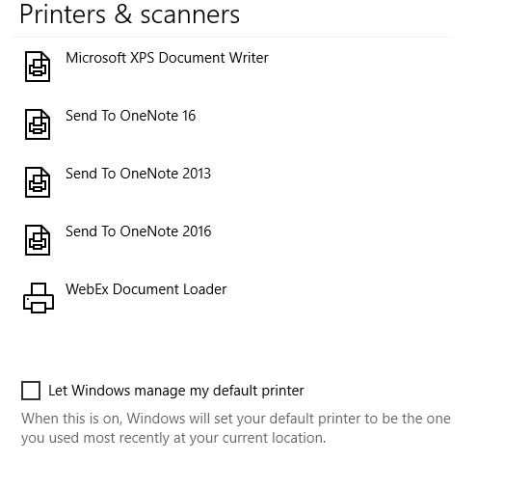

Simply set the default printer to Microsoft PDF writer. Double click on the printer then hit “manage”

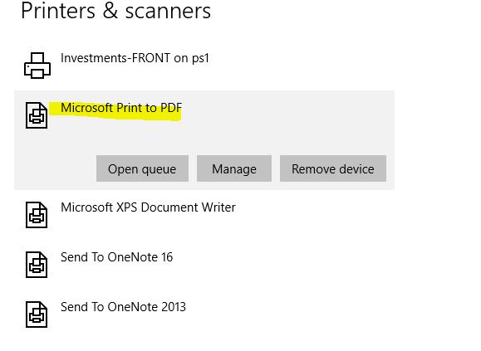

From the printer tab select “set as default printer”

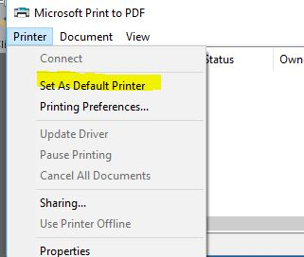

If desired you can also add a network printer

TO ADD A NETWORK PRINTER

Click on the start button type in [\\ps1](file:///\\ps1)

Double click on the printer you would like to add